# **GOVERNMENT POLYTECHNIC, AURANGABAD**

**(An Autonomous Institute of Government of Maharashtra)**

**“PERSUIT FOR EXCELLENCE” PROJECT REPORT**

**ON**

**“ANPR”**

**(Automated Number Plate Recognition)**

|  |  |
| --- | --- |
| **Ms. CHANCHAL ZOPE** | **(187003)** |
| **Ms. SHRUTI JAGTAP** | **(187010)** |
| **Ms. SAIPRAJAKTA KADAM** | **(187012)** |

**SUBMITED BY**

**GUIDED BY**

**Prof. P. P. DESHPANDE**

**DEPARTMENT OF INFORMATION TECHNOLOGY**

ACADEMIC YEAR 2020-21

# **DEPARTMENT OF INFORMATION TECHNOLOGY**

## **GOVERNMENT POLYTECHNIC, AURANGABAD**

**(An Autonomous Institute of Government of Maharashtra)**

**CERTIFICATE**

This is to certify that

1. **Ms. CHANCHAL ZOPE**
2. **Ms. SHRUTI JAGTAP**
3. **Ms. SAIPRAJAKTA KADAM**

has successfully completed project work- titled “**ANPR(AUTOMATED NUMBER PLATE RECOGNITION)”** during the academic year 2020-2021, in partial fulfillment of **Diploma in Information Technology** of Government Polytechnic, Aurangabad. To the best of our knowledge and belief this project work has not been submitted elsewhere.

**Date: 25/06/2020**

**Prof. P. P. DESHPANDE Prof. D. S. SONWANE**

**Project Guide H.O.D IT, CO**

**Prof. F. A. Khan**

**PRINCIPAL**

**ACKNOWLEDGEMENT**

We take an immense pleasure in thanking **Prof. F. A. Khan**, the principal, Government Polytechnic, Aurangabad, our source of inspiration. We wish to express our deep sense of gratitude to **Prof. D. S. Sonwane**, our respected Head of Department, Information Technology, and **Prof. P. P. Deshpande** our Guide for having permitted us to carry out this project under her valuable guidance and useful suggestions, which have helped us in completing the project in time.

We would also like to thank to all our faculty members of our department for their valuable suggestion in the process of this project work. Finally, yet importantly, we would like to express our thanks to our beloved parents for their blessings this entire work was possible because of their support only. Last but never the least, let us thanks our friends and classmates for their help and co-operation for the successful completion of this project.

|  |  |
| --- | --- |
| **Ms. CHANCHAL ZOPE** | **(187003)** |
| **Ms. SHRUTI JAGTAP** | **(187010)** |
| **Ms. SAIPRAJAKTA KADAM** | **(187012)** |

**INDEX**

Topic Page No.

***LIST OF FIGURES…………………………………………………………....i***

***ABSTRACT…………………………………………………………... iii***

1. **INTRODUCTION…………………………………………. 1**
   1. **PROJECT DESCRIPTION……………………………………… 1**
      1. History…………………………………………………………1
      2. Need of ANPR…………………………………………………1
      3. Literature Survey……………………………………………….2
      4. Objective of Project…………………………………………….3

1. **METHODOLOGY…………………………………………..5** 
   1. **Workflow of Project……………………………………………….5**
   2. **Block Diagram……………………………………………….……..7**
   3. **Tech Stack Used……………………………………………….…...8**
      1. Python……………………………………………………….8
      2. Html+CSS………………………………………….………..9
      3. Flask API…………………………………………….……..10
2. **IMPLEMENTATION…………………………………….. 11**
   1. **Why AI/Deep Learning Approach?.............................................. 11**
   2. **Dataset Preparation………………………………………………12**
   3. **Model Selection……………………………………………………13**
      1. SSD………………………………………………….....……14
      2. YOLO……………………………………………………….16
   4. **OCR…………………………………………………………..……..20**
   5. **Testing………………………………………………..……………..22**
   6. **Webapp Creation ………………………………….………………24**
3. **CODING…………………………………………………....27**
4. **RESULTS……………………………………………… 34**

**CONCLUSION………………………………………………………36**

***REFERENCES………………………………………………………* 37**

**LIST OF FIGURES**

|  |  |  |
| --- | --- | --- |
| **Figure No**. | **Title** | **Page No**. |
| 2.1 | Flow of project | 5 |
| 2.2 | Flow Chart of ANPR | 6 |
| 2.3 | Flow Chart of converting image to gray scale | 6 |
| 2.4 | Block Diagram of Project | 7 |
| 2.5 | Block diagram of ANPR | 8 |
| 3.1 | Machine Learning vs Deep Learning | 11 |
| 3.2 | Labelling Plate in LabelIMG | 12 |
| 3.3 | Prepared Dataset | 13 |
| 3.4 | Comparing various Object Detection models | 14 |
| 3.5 | SSD Architecture | 15 |
| 3.6 | Graph showing mAP of SSD | 16 |
| 3.7 | Prior Box of SSD | 16 |
| 3.8 | YOLO Architecture | 18 |
| 3.9 | Prior Bounding Boxes | 19 |
| 3.10 | Image Processing the number plate | 21 |
| 3.11 | Training Sets | 22 |
| 3.12 | Average Loss of Model | 23 |
| 3.13 | mAP of Model | 23 |

***Abstract*** *Automatic Number Plate Recognition (ANPR) is a highly accurate system capable of reading vehicle number plates without human intervention using Optical Character Recognizer (OCR).*

*Through the use of high speed image capture with supporting illumination, detection of characters within the images provided character recognition to convert image to text; so ending up with the set of metadata that identifies an image containing a vehicle license/number plate and the associated decoded text of that plate.*

*Most members of the public will be aware that ANPR is used by many police forces to track down criminals’ behavior and is also seen on many UK Motorways as a method of detecting speeding through average speed calculation. However, ANPR is used in a variety of other ways to support the security and safety of the public as well as supporting efficiencies in the way we interact with transportation and vehicle based infrastructure.*

*It is one of the applications of Artificial Intelligence 🡪 Machine Learning 🡪 Computer Vision.*

*Language used: Python*

*Backend: Html*

**Chapter 1**

**INTRODUCTION**

* 1. **PROJECT DESCRIPTION**

**1.1.1 HISTORY:**

[**Automatic number plate recognition**](https://en.wikipedia.org/wiki/Automatic_number_plate_recognition) (ANPR) is a technology for automatically reading [vehicle number plates](https://en.wikipedia.org/wiki/Vehicle_registration_plate). The [Home Office](https://en.wikipedia.org/wiki/Home_Office) states ANPR is used by law enforcement agencies in the [United Kingdom](https://en.wikipedia.org/wiki/United_Kingdom) to help detect, deter and disrupt criminality including tackling organised crime groups and terrorists.

Vehicle movements on UK roads are recorded by a network of 11,000 cameras that submit around 50 million ANPR "read" records to national ANPR systems daily. ANPR data from each police force is stored together with similar data from other forces for a period of one year, at the National ANPR Data Centre (NADC), which can be accessed, analysed and used as evidence as part of investigations by [UK law enforcement agencies](https://en.wikipedia.org/wiki/Law_enforcement_in_the_United_Kingdom).

The [Conservative – Liberal Democrat Coalition](https://en.wikipedia.org/wiki/Cameron%E2%80%93Clegg_coalition) government placed ANPR under statutory regulation through the [Protection of Freedoms Act 2012](https://en.wikipedia.org/wiki/Protection_of_Freedoms_Act_2012). This established a right in law to collect the data, and placed controls on its use, storage and access by third parties.

In August 2004 a presentation by John Dean, the Association of Chief Police Officers' (ACPO) National ANPR Co-ordinator at IFSEC revealed how ANPR was being used to 'deny criminals the use of the road'.

On 18 November 2005 [British police](https://en.wikipedia.org/wiki/Policing_in_the_United_Kingdom) [constable](https://en.wikipedia.org/wiki/Constable) [Sharon Beshenivsky](https://en.wikipedia.org/wiki/Sharon_Beshenivsky) was shot and killed during a robbery in [Bradford](https://en.wikipedia.org/wiki/Bradford). The [CCTV](https://en.wikipedia.org/wiki/Closed-circuit_television_camera) network was linked into an ANPR system and was able to identify the getaway car and track its movements, leading to the arrest of six suspects. At its launch in May, Ch Supt Geoff Dodd of West Yorkshire Police, called the ANPR system a "revolutionary tool in detecting crime".

In 2009, ANPR International develops its first mobile ANPR product – streetSWEEPER, hich is designed for multiple applications including traffic surveys, Mobile surveillance and untaxed vehicle enforcement for the driver and Vehicle Licensing Agency (DVLA). On this first day on the road in Central London, streetSWEEPER detects over 27 unwanted vehicles in just a few hours.

In 2018, the all new ASPEK Digital Camera range is launched which replaces our tried and tested D-ANPR range. The new range incorporates all new packages design with greater on board functionality and more features.

**1.1.2 NEED**

Unlike other countries, India, with its one billion people population, has a unique set of needs for ANPR.  The main use of ANPR is in highway monitoring, parking management, and neighborhood law enforcement security.

In India there is one death in every four minutes with most of them occurring due to over speeding.  ANPR is used to monitor the vehicles’ average speed and can identify the vehicles that exceed the speed limit.  In this case, a fine ticket can be automatically generated by calculating the distance between two cameras. This helps to maintain law and order which, in turn, can minimize the number of road casualties.

ANPR provides the best solution for providing parking management. Vehicles with registered plates can automatically enter into parking areas while non-registered vehicles will be charged by time of check in and check out. Number plates of the car can be directly linked with owner mobile phone and parking tickets could be paid without any extra effort directly from the user’s account against the ticket number generated. ANPR can support a cloud-based system pre-book and pre-pay platform for parking.

In India 200,000 cars are stolen per year. This number can lessen if proper steps are taken and ANPR system is used to track cars so that if vehicles are stolen, law enforcement will be able to identify when, where and the route taken by a stolen vehicle. This can help bring justice swiftly to such a vast nation.

Unlike other car parking barrier systems, an automatic number plate recognition system will allow you to only protect your car park, but monitor the access too. With ANPR cameras, you will have eyes on your park 24 hours and 7 days a week. You will know exactly who has entered your premised, the time they enter and also the time they leave. This cam be incredibly helpful in many situations.

**1.1.3 LITERATURE SURVEY**

Significant research and development of algorithms in intelligent transportation has grabbed more attention in recent years. An automated, fast, accurate and robust vehicle plate recognition system has become need for traffic control and law enforcement of traffic regulations; and the solution is ANPR. This paper is dedicated on animproved technique of OCR based license plate recognition using neural network trained dataset of object features.

A blended algorithm for recognition of license plate is proposed and is compared with existing methods for improve accuracy. The whole system can be categorized under three major modules, namely License Plate Localization, Plate Character Segmentation, and Plate Character Recognition. The system is simulated on 300 national and international motor vehicle LP images and results obtained justifies the main requirement.

Camera was incorporated to help in capturing the plate number images and it is

interfaced to a Raspberry pi processor for authentication. Using the Open Computer Vision (Open CV) and Optical Character Recognition (OCR), the system can extract numbers from the captured plate image and completely automate the license plate recognition. The experimental results from several testing in different locations and conditions show that the system performed better than most of the baseline studies considered.

Several License Plate Recognition systems have been developed in the past. Our objective is to design a system implemented on a standard camera-equipped mobile phone, capable of recognizing vehicle license number. As a first step towards it we propose a license plate text segmentation approach that is robust to various lighting conditions, complex background owing to dirty or rusted LP and non-convential fonts. In the Indian scenario, some vehicle owners choose to write their vehicle number plates in regional languages. Since our method does not rely on language-specific features, it is therefore capable of segmenting license number written in different languages. Using color connected component labeling, stroke width and text heuristics we perform the task of accurately segmenting the number from the license plate. Experiments carried out on Indian vehicle license plate (LP) images acquired using a camera-equipped cellphone shows that our system performs well on different LP images some with different types of degradations. OCR evaluation on the extracted LP number text with the proposed method has an accuracy of 98.86%

2019 2nd International Conference on Intelligent Communication and Computational Techniques (ICCT). Automatic license plate recognition is being widely used for numerous applications since its inception. The ability to procure license plate numbers accurately has been beneficial in maintaining traffic rules, parking enforcement, and security. In this paper, we have discussed the results of using ALPR for recognition of anonymous vehicles entering our university campus. We used deep learning for license plate localization and Tesseract OCR for license plate recognition. By doing so we could read the license plates of vehicles entering a particular campus and verify if the vehicle are authorized by comparing it with a predefined list of authorized vehicles.

**1.1.4 OBJECTIVE**

The project´s objective is to develop a character recognition system for a license plate of a car using the techniques and tools that best suit this purpose and allow doing it in and easy and comfortable way.

More specially the project’s objectives are:

* Find a method with acceptable results for the correct location of the area of the license plate.
* Build a system that given an image region where plate can be found, to determine the character of the same.
* Recognize each character we have extracted above by OCR system.
* Based on the character recognized show the map of state from where the vehicle was sold.

**Chapter 2**

**METHODOLOGY**

**2.1 WORK FLOW OF PROJECT:**

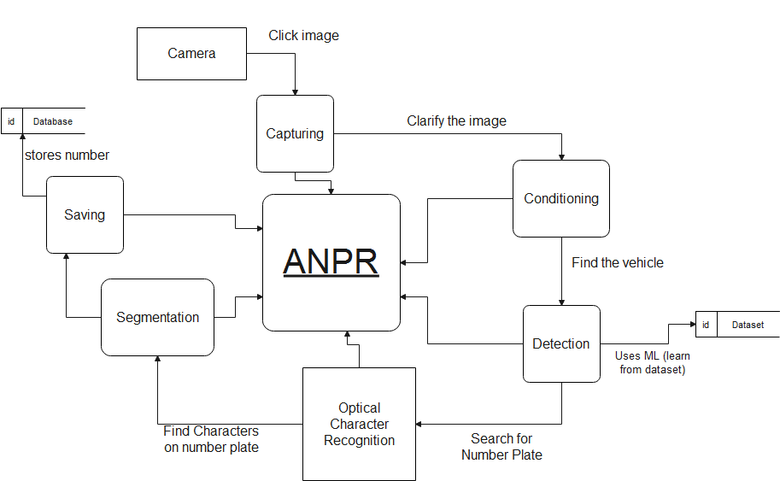

Fig. 2.1 Flow of project

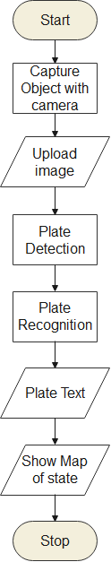

Fig 2.2 Flow Chart of ANPR

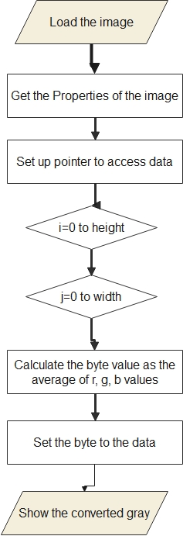

Fig 2.3 Flow Chart of converting image to gray scale

**2.2 BLOCK DIAGRAM:**

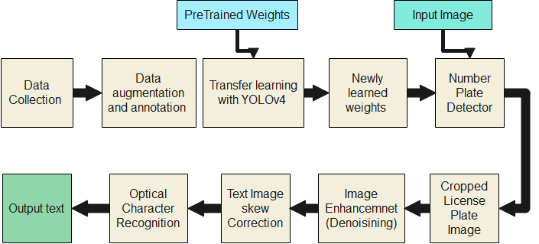

Fig. 2.4 Block Diagram of Project

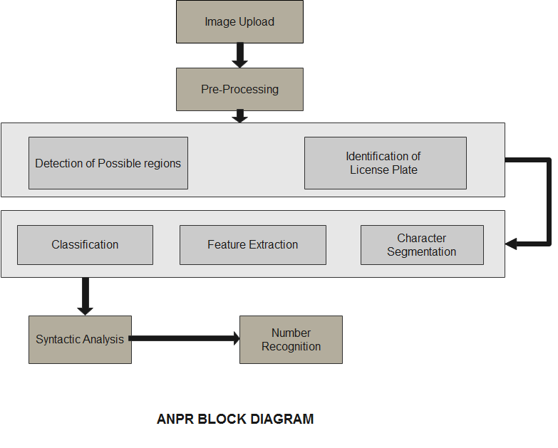

Fig. 2.5 Block diagram of ANPR

**2.3 TECH STACK USED**

|  |  |  |
| --- | --- | --- |
| Backend | : | Python |
| Frontend | : | Html+CSS |
| Supporting | : | Flask API |

**2.3.1 Python**



Python is by far the most popular programming language for Machine Learning. Python is so popular and consequently why it is best-suited for ML. Some of these reasons for this are given as follows:

1. Python is Easy To Use

Nobody likes excessively complicated things and so the ease of using Python is one of the main reasons why it is so popular for Machine Learning. It is **simple** with an **easily readable syntax** and that makes it well-loved by both seasoned developers and experimental students. The simplicity of Python means that developers can focus on actually solving the Machine Learning problem rather than spend all their time (and energy!) understanding just the technical nuances of the language.

In addition to this, Python is also **supremely efficient**. It allows developers to complete more work using fewer lines of code. The Python code is also easily understandable by humans, which makes it ideal for making Machine Learning models. With all these advantages, what’s not to love?!!

1. Python has multiple Libraries and Frameworks

Python is already quite popular and consequently, it has hundreds of different libraries and frameworks that can be used by developers. These libraries and frameworks are really useful in saving time which in turn makes Python even more popular (That’s a beneficial cycle!!!).

There are many Python libraries that are specifically useful for Artificial Intelligence and Machine Learning. Some of these are given below:

* **Keras** is an open-source library that is particularly focused on experimentation with deep neural networks.
* **TensorFlow** is a free software library that is used for many machine learning applications like neural networks. (They seem to be quite popular!)
* **Scikit-learn** is a free software library for Machine Learning that various classification, regression and clustering algorithms related to this. Also, Scikit-learn can be used in conjugation with NumPy and SciPy.

1. **Python is Portable and Extensible**

This is an important reason why Python is so popular in Machine Learning. A lot of cross-language operations can be performed easily on Python because of its **portable and extensible nature**. There are many data scientists who prefer using Graphics Processing Units (GPUs) for training their ML models on their own machines and the portable nature of Python is well suited for this.

Also, many different platforms support Python such as Windows, Macintosh, Linux, Solaris, etc. In addition to this, Python can also be integrated with Java, .NET components or [C](https://www.geeksforgeeks.org/c-programming-language/)/[C++](https://www.geeksforgeeks.org/c-plus-plus/) libraries because of its extensible nature.

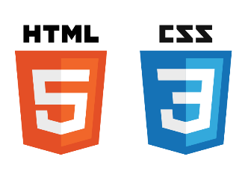**2.3.2 Html+CSS**

HTML(the Hypertext Markup Language) and [CSS](https://www.w3.org/Style/CSS/) (Cascading Style Sheets) are two of the core technologies for building Web pages. HTML provides the structure of the page, CSS the (visual and aural) layout, for a variety of devices. Along with [graphics](https://www.w3.org/standards/webdesign/graphics) and [scripting](https://www.w3.org/standards/webdesign/script), HTML and CSS are the basis of building Web pages and Web Applications.

  HTML is the language for describing the structure of Web pages. HTML gives authors the means to:

* Publish online documents with headings, text, tables, lists, photos, etc.
* Retrieve online information via hypertext links, at the click of a button.
* Design forms for conducting transactions with remote services, for use in searching for information, making reservations, ordering products, etc.
* Include spread-sheets, video clips, sound clips, and other applications directly in their documents

CSS is the language for describing the presentation of Web pages, including colors, layout, and fonts. It allows one to adapt the presentation to different types of devices, such as large screens, small screens, or printers. CSS is independent of HTML and can be used with any XML-based markup language. The separation of HTML from CSS makes it easier to maintain sites, share style sheets across pages, and tailor pages to different environments. This is referred to as the separation of structure (or: content) from presentation.

**2.3.3 Flask API**

Flask is a lightweight [Web Server Gateway Interface WSGI web application](https://wsgi.readthedocs.io/en/latest/learn.html) framework that was created to make getting started easy and making it easy for new beginners. With the tendency to scale up to complex applications.

Flask has its foundation around [Werkzeug](https://pypi.org/project/Werkzeug/) and [Jinja2](https://jinja.palletsprojects.com/en/2.10.x/) and has become one of the most popular Python web application frameworks.

As a developer in developing a web app in python, you may be using a framework to your advantage. A framework is a code storage that should help developers achieve the required result by making work easier, scalable, efficient and maintainable web applications by providing reusable code or extensions for common operations.

These frameworks for Python comes in different ways, owned and created by different people. Examples are; [Flask](https://flask.palletsprojects.com/), [Tornado](https://www.tornadoweb.org/), [Django](https://www.djangoproject.com/), e.t.c.

Flask gives the developer varieties of choice when developing web applications, it provides you with tools, libraries, and mechanics that allow you to build a web application but it will not enforce any dependencies or tell you how the project should look like.

**CHAPTER 3**

**IMPLEMENTATION**

* 1. **WHY AI/DEEP LEARNING APPROACH ?**

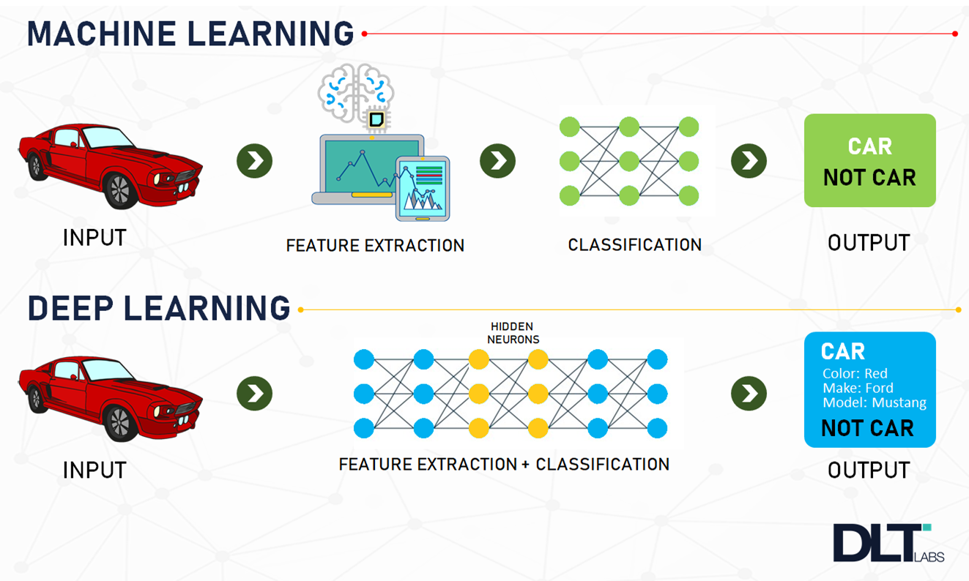Automatic Number Plate Recognition nowadays plays an inevitable role in several applications. Though the ANPR uses several algorithms it still fails in the case of accuracy and implementation in real time. It can be overcome by implementing it using deep learning techniques. Deep learning is a vast field of Artificial intelligence (AI) which uses neural nets to learn from a huge amount of data. It is a subset of Machine Learning which uses multiple layers to get high level features from a raw input. Deep Learning is now used in almost all the real time applications. Unlike other algorithms, it shows a high level of accuracy and minimum acceptable errors. This system uses Convolutional Neural network(CNN) to detect the cars and number plate. The main aim of the system is to design a deep learning model that could read the number plate of the fast moving vehicles on the road using the surveillance camera and save the extracted number plate data.

Fig. 3.1 Machine Learning vs Deep Learning

Deep Learning has following advantages:

* Maximum Utilization of Unstructured Data

Research from Gartner revealed that a huge percentage of an organization’s data is unstructured because the majority of it exists in different types of formats like pictures, texts etc. For the majority of[machine learning](http://becominghuman.ai/)algorithms, it’s difficult to analyze unstructured data, which means it’s remaining unutilized and this is exactly where **deep learning** becomes useful.

You can use different data formats to train **deep learning** algorithms and still obtain insights which are relevant to the purpose of the training. For instance, you can use **deep learning** algorithms to uncover any existing relations between industry analysis, social media chatter, and more to predict upcoming stock prices of a given organization.

* Ability to deliver high quality results

Humans get hungry or tired and sometimes make careless mistakes. When it comes to neural networks, this isn’t the case. Once trained properly, a **deep learning** model becomes able to perform thousands of routine, repetitive tasks within a relatively shorter period of time compared to what it would take for a human being. In addition, the quality of the work never degrades, unless the training data contains raw data which doesn’t represent the problem you’re trying to solve.

**3.2 DATASET PREPARATION**

The first part of an ANPR project is to collect data and a mass enough example plates under various conditions. This process provides a context in which we can consider the data preparation required for the project, informed both by the definition of the project performed before data preparation and the evaluation of machine learning algorithms performed after.

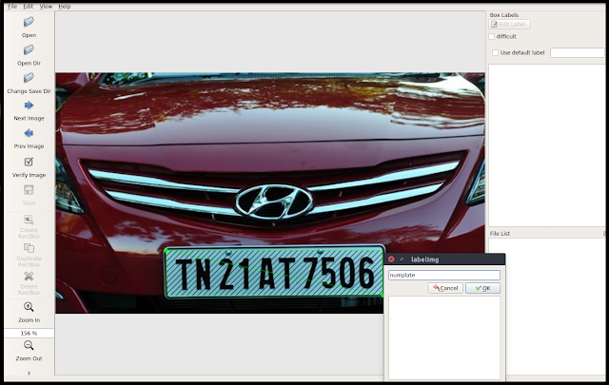

Fig. 3.2 Labelling Plate in LabelIMG

In this project we have used “LabelIMG” tool to prepare the datasets. **LabelImg** is a free, open source tool for graphically labelling images. It's written in Python and uses QT for its graphical interface. It's an easy, free way to label a few hundred images to try out your next project.

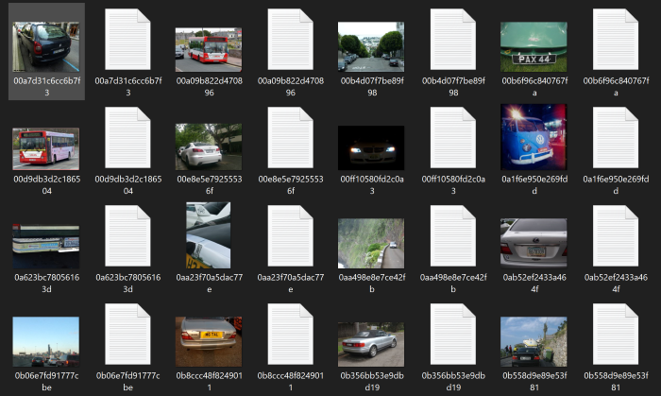

Fig 3.3 Prepared Dataset

LabelImg supports labelling in [**VOC XML**](https://roboflow.com/formats/pascal-voc-xml) or [**YOLO text**](https://roboflow.com/formats/yolo-darknet-txt) file format. At Roboflow, **we strongly recommend you use the default VOC XML** format for creating labels. Thanks to ImageNet, VOC XML is a more universal standard as it relates to [**object detection**](https://models.roboflow.ai/object-detection) whereas various [**YOLO implementations**](https://models.roboflow.ai/object-detection/yolov4) have slightly different text file formats. Moreover, you can always easily [**convert from VOC XML**](https://roboflow.com/formats/pascal-voc-xml) to any other format using Roboflow, like [**VOC XML to COCO JSON**](https://blog.roboflow.com/how-to-convert-annotations-from-voc-xml-to-coco-json/).

We have collected 800 car number plate images having variety of different properties and cars at different angles. From these 800 images, 600 are used to prepare the dataset using LabelIMG tool and 200 images are used to test the model.

**3.3 MODEL SELECTION**

Model selection is the process of selecting one [final machine learning model](https://machinelearningmastery.com/train-final-machine-learning-model/) from among a collection of candidate machine learning models for a training dataset.

Model selection is a process that can be applied both across different types of models (e.g. logistic regression, SVM, KNN, etc.) and across models of the same type configured with different model hyper-parameters (e.g. different kernels in an SVM).

All models have some predictive error, given the statistical noise in the data, the incompleteness of the data sample, and the limitations of each different model type. Therefore, the notion of a perfect or best model is not useful. Instead, we must seek a model that is “good enough.”

One can use the following object models for object detection:

• Fast R-CNN

• Faster R-CNN

• Histogram of Oriented Gradients (HOG)

• Region-based Convolutional Neural Networks (R-CNN)

• Region-based Fully Convolutional Network (R-FCN)

• Single Shot Detector (SSD)

• Spatial Pyramid Pooling (SPP-net)

• YOLO (You Only Look Once)

Among these we have used SSD algorithm while developing WebApp of ANPR and YOLOv4 algorithm for creating number plate detection model in Google Colab.

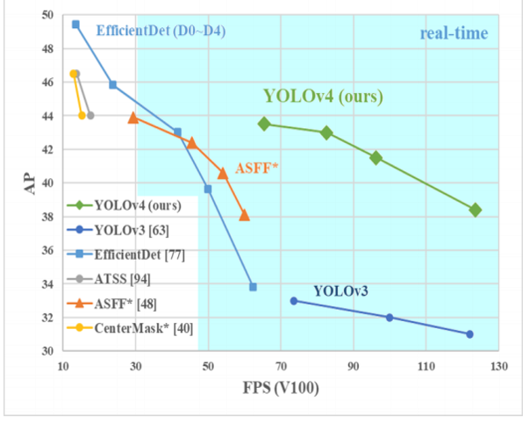

Fig. 3.4 Comparing various Object Detection models

In our ANPR model in Google Colab we have used YOLOv4. The reason is, it mAP is best at real-time as compare to other versions.

**3.3.1 SSD**

SSD stands for Single Shot MultiBox Detector, is a target detection algorithm proposed by Wei Liu at ECCV 2016. As of now, it is one of the main detection frameworks. Compared with Faster RCNN, it has a clear speed advantage, and it has YOLO Obvious mAP advantage (but has been surpassed by CVPR 2017's YOLO9000). SSD has the following main features:

1. Inherited the idea of ​​converting detection to regression from YOLO, and completed network training at one time
2. Based on anchor in Faster RCNN, a similar priority box is proposed.
3. Adding a detection method based on the Pyramidal Feature Hierarchy, which is equivalent to half a FPN idea.

The SSD algorithm proposed in this paper is a multi-target detection algorithm that directly predicts the target category and bounding box . Compared with faster rcnn, this algorithm does not generate a proposal process, which greatly improves the detection speed. For different sizes of target detection, the traditional approach is to first convert the images into different sizes (image pyramids), then detect them separately, and finally combine the results.

The SSD algorithm uses feature maps of different convolutional layers to achieve the same effect. The main network structure of the algorithm is VGG16. The last two fully connected layers are changed to convolutional layers, and then four convolutional layers are added to construct the network structure.

Wherein the output of the convolution of 5 different layers (feature map) each with two different 3 × 3 convolution kernel for convolution output a classification of confidence , each default box generates confidence categories 21; a Output localization for regression, each default box generates 4 coordinate values (x, y, w, h). In addition, these five feature maps also generate a priority box (the coordinates are generated) through the PriorBox layer. The number of default boxes for each layer in the above five feature maps is given (8732). Finally, the first three calculation results are combined and passed to the loss layer.

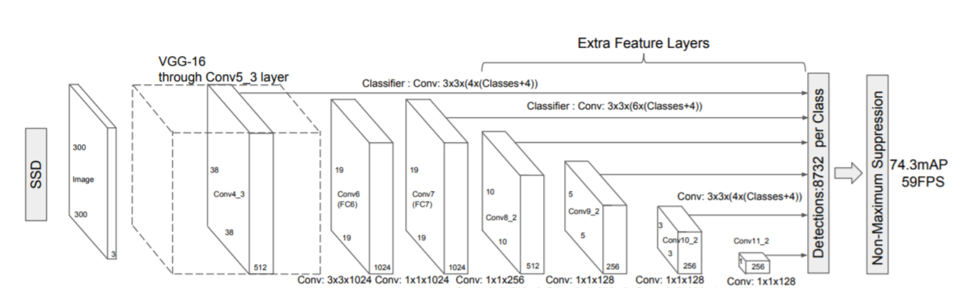

Fig. 3.5 SSD Architecture

Figure 3.4 above shows the structure of the SSD 300 network in the original paper. It can be seen that YOLO is followed by a fully connected layer after the convolution layer, that is, only the highest-level feature maps (including Faster RCNN) are used for detection; and the SSD uses the feature pyramid structure for detection, that is, conv4-3 is used for detection. , Feature maps with different sizes, conv-7 (FC7), conv6-2, conv7-2, conv8_2, conv9_2, perform softmax classification and position regression on multiple feature maps at the same time.

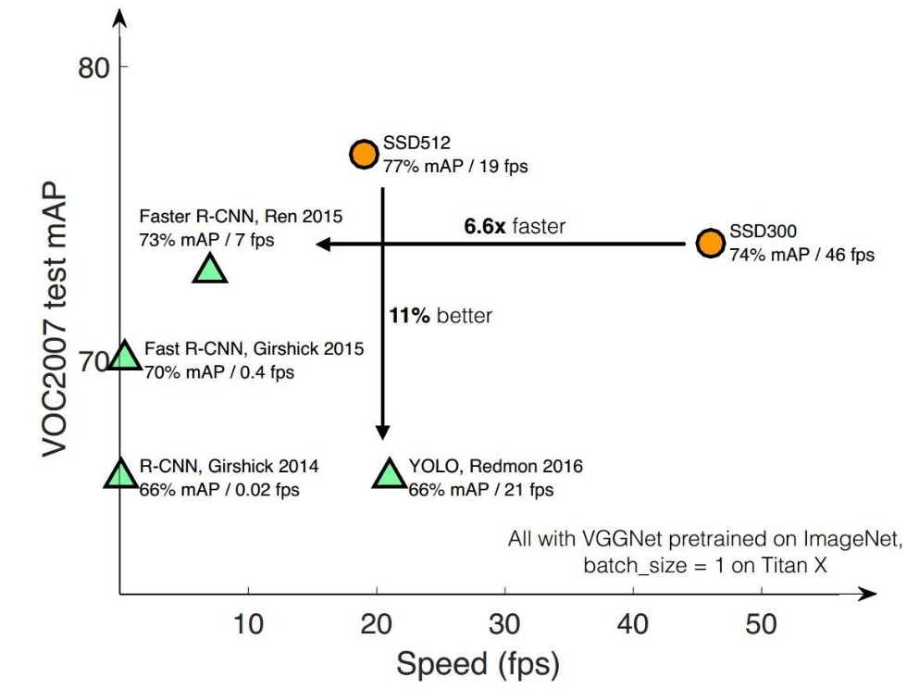

Fig. 3.6. Graph showing mAP of SSD

**Prior Box**: The indentation introduces the Prior Box in the SSD. In fact, it is very similar to the anchor. It is a pre-selection box for some targets, and then the position of the real target is obtained through softmax classification + bounding box regression. The SSD generates a priority box according to the following rules:

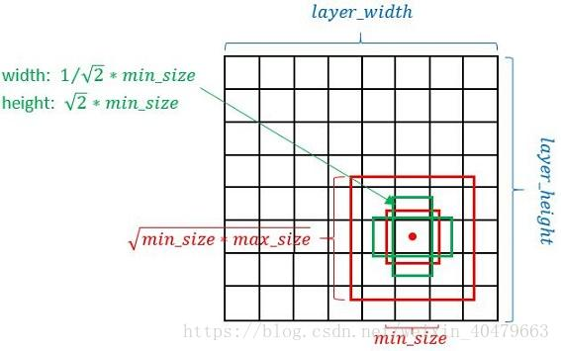

Fig. 3.7. Prior Box of SSD

Take the midpoint of each point on the feature map as the center (offset = 0.5), generate a series of concentric priority boxes (then the coordinates of the center point will be multiplied by step, which is equivalent to mapping from the feature map position back to the original map position)

The minimum side length of a square priority box is min_size and the maximum side length is: √(minsize∗maxsize)

For each aspect ratio set in prototxt , 2 rectangles will be generated, the length and width are: √(aspectratio∗minsize) and 1/ √(apectratio∗minsize)

The min_size and max_size of each feature map corresponding to the priority box are determined by the following formula, where m is the number of feature maps used (m = 6 in SSD 300).

Advantages and Disadvantages of SSD Network Structure:

The advantages of the indented SSD algorithm should be obvious: the running speed is comparable to YOLO, and the detection accuracy is comparable to Faster RCNN. In addition, there are some trivial advantages that are not explained.

Talk about the disadvantages here:

* We need to manually set the min_size, max_size, and aspect_ratio values ​​of the priority box. The basic size and shape of the priority box in the network cannot be directly obtained through learning, but need to be set manually. The size and shape of the priority boxes used by each layer of features in the network are exactly the same, resulting in the debugging process being very dependent on experience.
* Although the idea of ​​the pyramid feature hierarchy is adopted, the recall of small targets is still average and has not reached the level of crushing Faster RCNN. The author believes that this is because SSD uses conv4_3 low-level features to detect small targets, while the number of low-level feature convolutional layers is small, and there is a problem of insufficient feature extraction.

**3.3.2 YOLO**

You Only Look Once(YOLO) is a state-of-the-art, real-time object detection system. On a Pascal Titan X it processes images at 30 FPS and has a mAP of 57.9% on COCO test-dev.

YOLOv4 was a real-time object detection model published in April 2020 that achieved state-of-the-art performance on the COCO dataset. It works by breaking the object detection task into two pieces, regression to identify object positioning via bounding boxes and classification to determine the object's class. This implementation of YoloV4 uses the Darknet framework.

By using YOLOv4, you are implementing many of the past research contributions in the YOLO family along with a series of new contributions unique to YOLOv4 including new features: WRC, CSP, CmBN, SAT, Mish activation, Mosaic data augmentation, CmBN, DropBlock regularization, and CIoU loss. In short, with YOLOv4, you're using a better object detection network architecture and new data augmentation techniques.

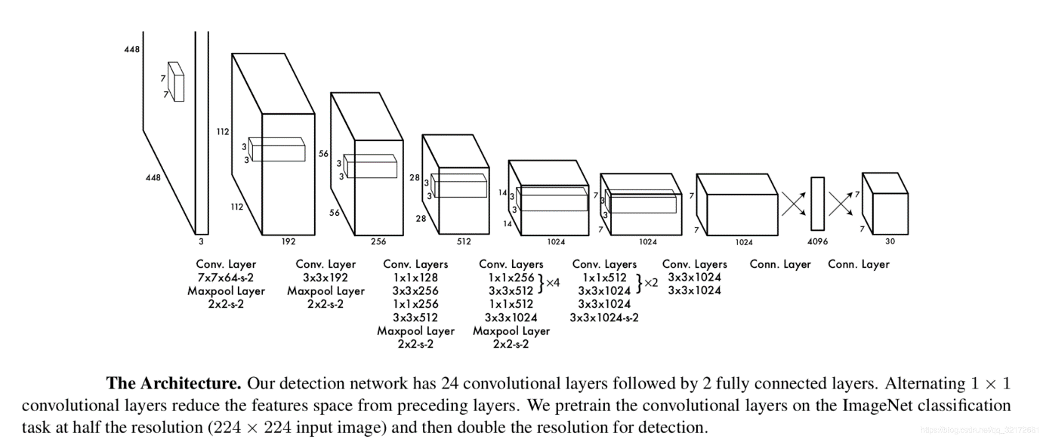

Fig. 3.8 YOLO Architecture

Network Architecture and Training:

Changes to loss functions for better results is interesting. Two things stand out:

1. Differential weight for confidence predictions from boxes that contain object and boxes that dont contain object during training.
2. predict the square root of the bounding box width and height to penalize error in small object and large object differently.

Our network has 24 convolutional layers followed by 2 fully connected layers. Instead of the inception modules used by GoogLeNet, we simply use 1 × 1 reduction layers followed by 3 × 3 convolutional layers

Fast YOLO uses a neural network with fewer convolutional layers (9 instead of 24) and fewer filters in those layers. Other than the size of the network, all training and testing parameters are the same between YOLO and Fast YOLO.

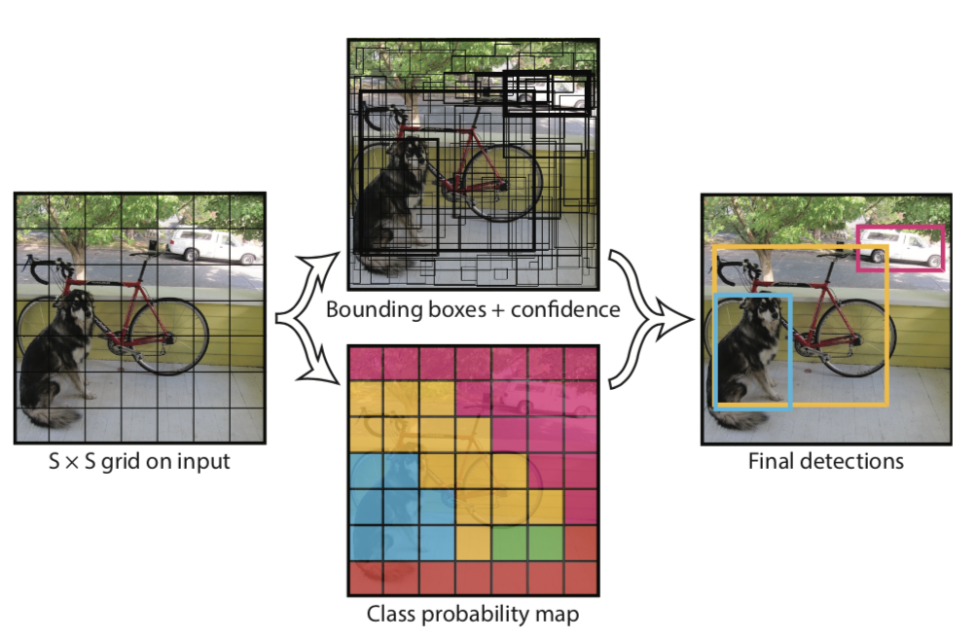

Fig. 3.9 Prior Bounding Boxes

YOLO4 uses three different scales to predict the boxes. The network uses a similar feature pyramid concept to extract features from different scales. Several new convolutional layers were added to the original basic feature extractor . Finally, a 3-dimensional tensor was used to represent the bounding box, objectness, and class predictions. In COCO, 3 boxes are predicted on each scale, so the tensor is N * N * [3 * (4 + 1 + 80)], which corresponds to 4 bounding boxes, 1 objectness prediction, and 80 class predictions, respectively. . Next, extract the feature map from the previous two layers and upsample it 2 times. Take a feature map from an earlier network and use tandem to merge it with the up-sampled features. This approach allows us to obtain more meaningful semantic information from the up-sampled features and finer-grained information from earlier feature maps. Then add some convolutional layers to process this combined feature map, and finally predict a similar tensor , although it is now twice the size. Perform the same design again to predict the size of the final box. In the past, YOLO had difficulty predicting small objects, but now it has improved significantly through multi-scale prediction.

**3.4 OCR**

Optical Character Recognition, or OCR, is a technology that enables you to convert different types of documents, such as scanned paper documents, PDF files or images captured by a digital camera into editable and searchable data.

Imagine you’ve got a paper document - for example, magazine article, brochure, or PDF contract your partner sent to you by email. Obviously, a scanner is not enough to make this information available for editing, say in Microsoft Word. All a scanner can do is create an image or a snapshot of the document that is nothing more than a collection of black and white or color dots, known as a raster image. In order to extract and repurpose data from scanned documents, camera images or image-only PDFs, you need an OCR software that would single out letters on the image, put them into words and then, words into sentences, thus enabling you to access and edit the content of the original document.

The image processing which we shall implement on our image is:

* **Convert to 255 scale.**Extracted license image from Wpod-Net is interpreted as 0–1 scale, thus we need to convert it to 8-bit scale as standard image.
* **Convert to grayscale**. Color plays an negligible role to understand the license plate, thus we can remove it to optimize computational power.
* **Blur image.**Blur technique is performed to remove noise and irrelevant information. In the example code, I used Gaussian Blur with kernel size of (7,7) but this value can be tuned depending on your image. The higher of the kernel size, the less noise but more information is lost.
* **Image thresholding.** We set a threshold so that any smaller pixel value than it would be converted to 255 and vice versa. This type of thresholding is called*inverse binary thresholding .* In the example code, I used threshold value of 180, this value can be modified to be more compatible with your image.
* **Dilation.**This is a technique to increase the white region of the image. By implementing *dilation*, we want to enhance the white contour of each character,

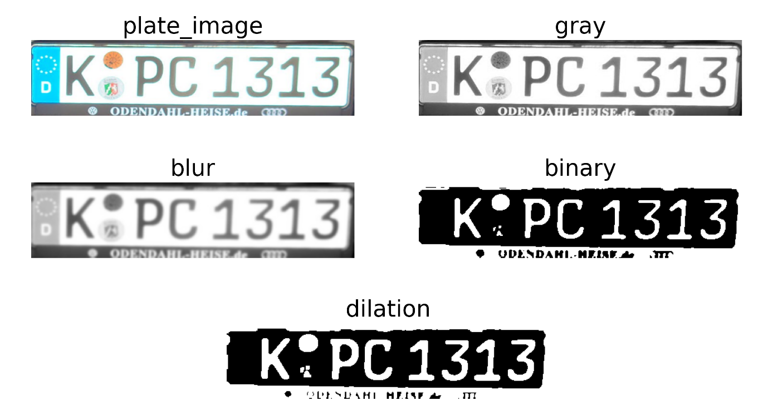

Fig. 3.10 Image Processing the number plate

The dark areas are then processed further to find alphabetic letters or numeric digits. OCR programs can vary in their techniques, but typically involve targeting one character, word or block of text at a time. Characters are then identified using one of two algorithms:

1. [Pattern recognition](https://whatis.techtarget.com/definition/pattern-recognition)- OCR programs are fed examples of text in various fonts and formats which are then used to compare, and recognize, characters in the scanned document.
2. Feature detection- OCR programs apply rules regarding the features of a specific letter or number to recognize characters in the scanned document. Features could include the number of angled lines, crossed lines or curves in a character for comparison. For example, the capital letter “A” may be stored as two diagonal lines that meet with a horizontal line across the middle.

When a character is identified, it is converted into an [ASCII](https://whatis.techtarget.com/definition/ASCII-American-Standard-Code-for-Information-Interchange) code that can be used by computer systems to handle further manipulations. Users should correct basic errors, proofread and make sure complex layouts were handled properly before saving the document for future use.

**3.5 TESTING**

Model testing is referred to as the process where the performance of a fully trained model is evaluated on a testing set. ... There are a number of statistical metrics that can be used to assess testing results including mean squared errors and receiver operating characteristics curves.

In machine learning, a programmer usually inputs the data and the desired behavior, and the logic is elaborated by the machine. This is especially true for deep learning. Therefore, the purpose of machine learning testing is, first of all, to ensure that this learned logic will remain consistent, no matter how many times we call the program.

First of all, you split the database into three non-overlapping sets. You use a training set to train the model. Then, to evaluate the performance of the model, you use two sets of data:

* **Validation set.** Having only a training set and a testing set is not enough if you do many rounds of hyperparameter-tuning (which is always). And that can result in overfitting. To avoid that, you can select a small validation data set to evaluate a model. Only after you get maximum accuracy on the validation set, you make the testing set come into the game.

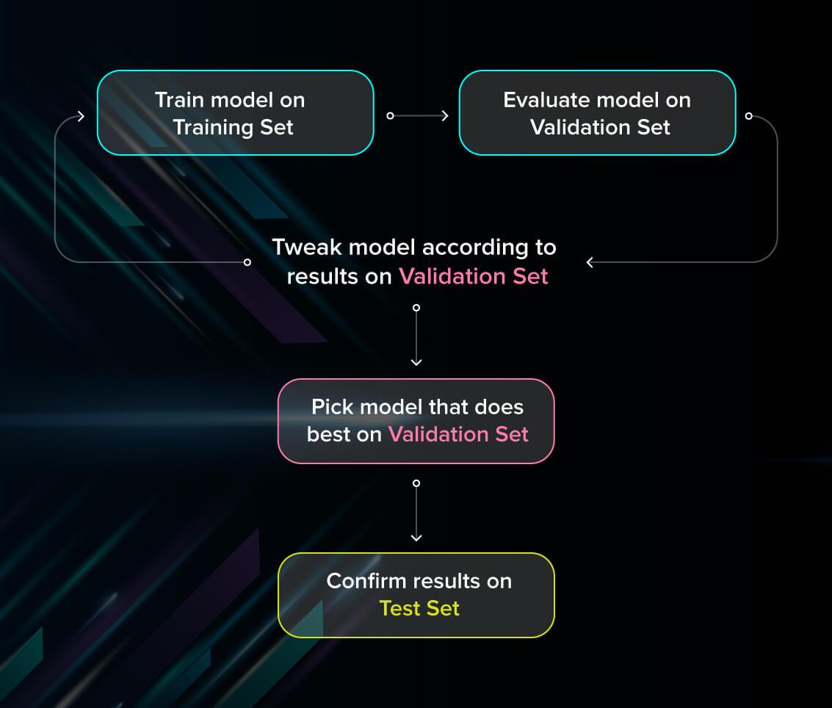

Fig. 3.11 Training Sets

* **Test set (or holdout set).** Your model might fit the training dataset perfectly well. But where are the guarantees that it will do equally well in real-life? In order to assure that, you select samples for a testing set from your training set — examples that the machine hasn’t seen before. It is important to remain unbiased during selection and draw samples at random. Also, you should not use the same set many times to avoid training on your test data. Your test set should be large enough to provide statistically meaningful results and be representative of the data set as a whole.

Evaluate models using metrics

Evaluating the performance of the model using different metrics is integral to every data science project. Here is what you have to keep an eye on:

Loss

Loss describes the percentage of bad predictions. If the model’s prediction is perfect, the loss is zero; otherwise, the loss is greater.

Our model has loss as 0.02%

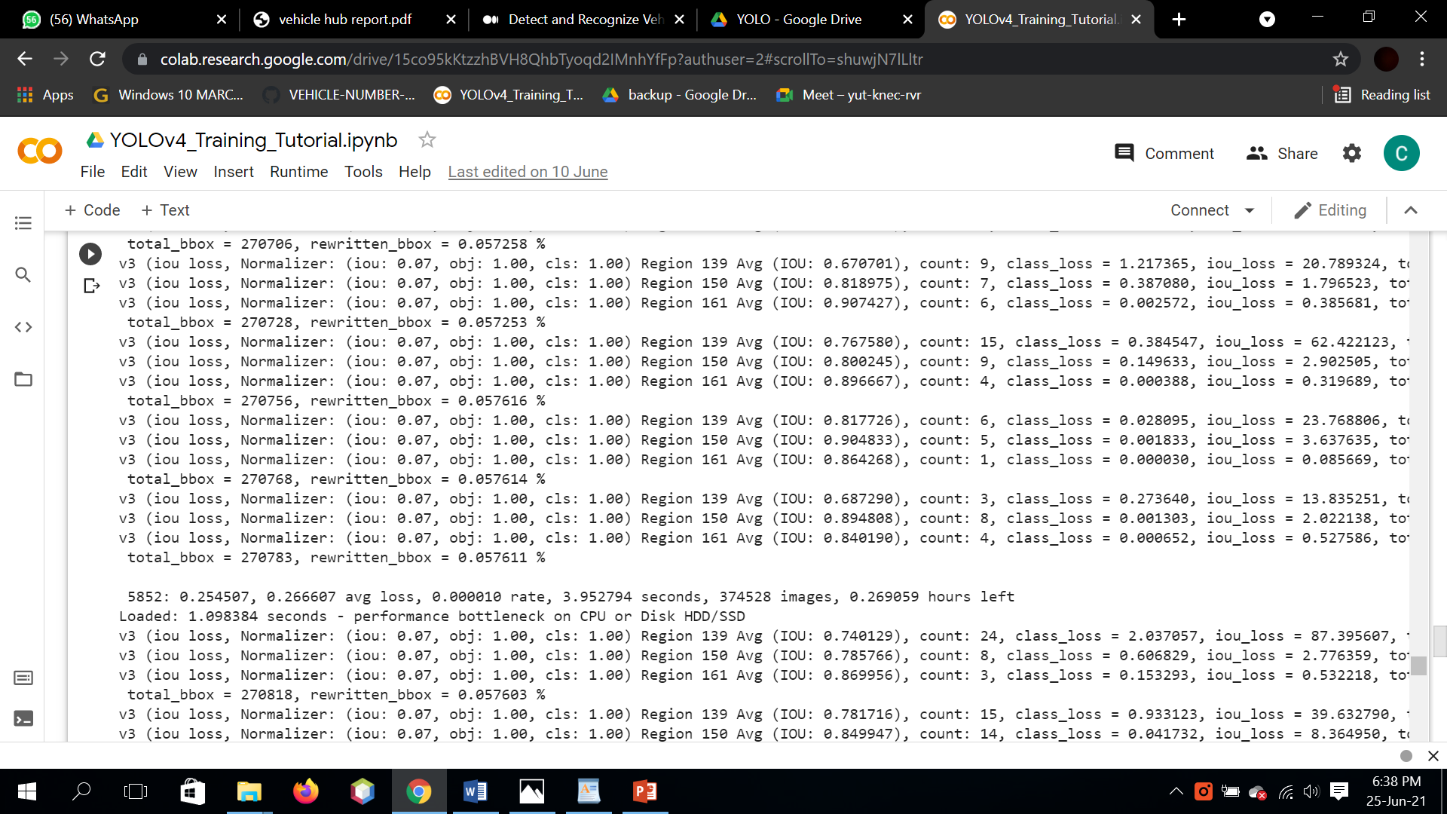

Fig 3.12 Average Loss of Model

Precision

The precision metric marks how often the model is correct when identifying positive results. For example, how often the model diagnoses cancer to patients who really have cancer.

$$Precision \equiv \frac{True\ Positives}{True\ Positives + False\ Positives}$$

Our model has mAP i.e. Mean Average Precision of almost 90%.

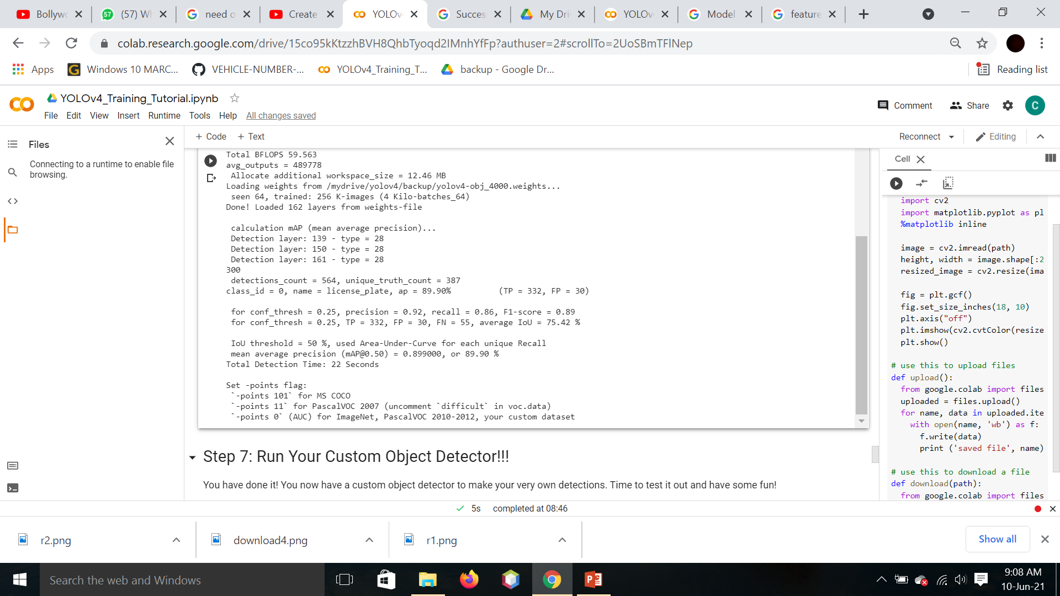

Fig. 3.13 mAP of Model

**3.6 WEBAPP CREATION**

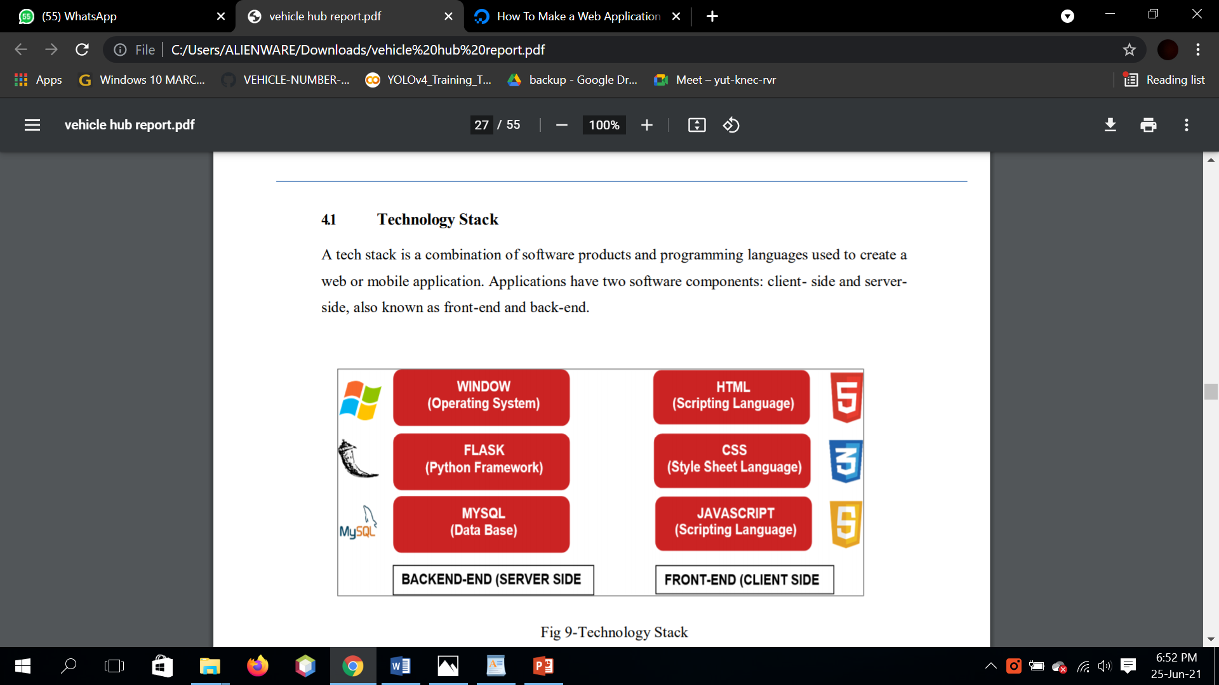

PYTHON

Fig. 3.14 Tech used in webapp creation

**3.6.1 Operating System**

Windows Although most computers now a days probably have the necessary requirements for Windows10. It will certainly be useful to know the min case you want to upgrade from an older system.

The main requirements are –

* A processor (CPU) with a clock rate of at least1GHz.
* At least 1 to 2GB of memory (RAM), but Microsoft recommends 4GB.
* At least 16GB space in your hard disk.
* 4GB GPU support

**3.6.2 Python Libraries**



TensorFlow is an end-to-end open source platform for machine learning. It has a comprehensive, flexible ecosystem of tools, libraries and community resources that lets researchers push the state-of-the-art in ML and developers easily build and deploy ML powered applications.

TensorFlow offers multiple levels of abstraction so you can choose the right one for your needs. Build and train models by using the high-level Keras API, which makes getting started with TensorFlow and machine learning easy.

If you need more flexibility, eager execution allows for immediate iteration and intuitive debugging. For large ML training tasks, use the Distribution Strategy API for distributed training on different hardware configurations without changing the model definition.

Build and train state-of-the-art models without sacrificing speed or performance. TensorFlow gives you the flexibility and control with features like the Keras Functional API and Model Subclassing API for creation of complex topologies. For easy prototyping and fast debugging, use eager execution.

TensorFlow also supports an ecosystem of powerful add-on libraries and models to experiment with, including Ragged Tensors, TensorFlow Probability, Tensor2Tensor and BERT.



**NumPy** brings the computational power of languages like C and Fortran to **Python**, a language much easier to learn and use.

NumPy forms the basis of powerful machine learning libraries like [scikit-learn](https://scikit-learn.org/) and [SciPy](https://www.scipy.org/). As machine learning grows, so does the list of libraries built on NumPy. [TensorFlow’s](https://www.tensorflow.org/) deep learning capabilities have broad applications — among them speech and image recognition, text-based applications, time-series analysis, and video detection. [PyTorch](https://pytorch.org/), another deep learning library, is popular among researchers in computer vision and natural language processing. [MXNet](https://github.com/apache/incubator-mxnet) is another AI package, providing blueprints and templates for deep learning.

Statistical techniques called [ensemble](https://towardsdatascience.com/ensemble-methods-bagging-boosting-and-stacking-c9214a10a205) methods such as binning, bagging, stacking, and boosting are among the ML algorithms implemented by tools such as [XGBoost](https://github.com/dmlc/xgboost), [LightGBM](https://lightgbm.readthedocs.io/en/latest/), and [CatBoost](https://catboost.ai/) — one of the fastest inference engines. [Yellowbrick](https://www.scikit-yb.org/en/latest/) and [Eli5](https://eli5.readthedocs.io/en/latest/) offer machine learning visualizations.



OpenCV (Open Source Computer Vision Library) is an open source computer vision and machine learning software library. OpenCV was built to provide a common infrastructure for computer vision applications and to accelerate the use of machine perception in the commercial products. Being a BSD-licensed product, OpenCV makes it easy for businesses to utilize and modify the code.

The library has more than 2500 optimized algorithms, which includes a comprehensive set of both classic and state-of-the-art computer vision and machine learning algorithms. These algorithms can be used to detect and recognize faces, identify objects, classify human actions in videos, track camera movements, track moving objects, extract 3D models of objects, produce 3D point clouds from stereo cameras, stitch images together to produce a high resolution image of an entire scene, find similar images from an image database, remove red eyes from images taken using flash, follow eye movements, recognize scenery and establish markers to overlay it with augmented reality, etc. OpenCV has more than 47 thousand people of user community and estimated number of downloads exceeding [18 million](https://sourceforge.net/projects/opencvlibrary/files/stats/timeline?dates=2001-09-20+to+2019-01-30). The library is used extensively in companies, research groups and by governmental bodies.

PyTorch is an optimized tensor library primarily used for Deep Learning applications using GPUs and CPUs. It is an open-source machine learning library for Python, mainly developed by the Facebook AI Research team. It is one of the widely used Machine learning libraries, others being TensorFlow and Keras. Here is the Google Search Trends which shows that the popularity of the PyTorch library is relatively higher compared to TensorFlow and Keras.

PyTorch is built based on python and torch library which supports computations of tensors on Graphical Processing Units. Currently is the most favored library for the deep learning and artificial intelligence research community.

PyTorch is a library for processing tensors. A tensor is a fundamental unit of data. It can be a number, vector, matrix, or any n-dimensional array. It is similar to Numpy arrays.

**CHAPTER 4**

**CODING**

**Python Code (Web App):**

# importing the necessary dependencies

from flask import Flask, render_template, request, send_file

from flask_cors import CORS, cross_origin

import numpy as np

import os

import tensorflow as tf

import easyocr as ocr

import cv2

from object_detection.utils import label_map_util

os.putenv('LANG', 'en_US.UTF-8')

os.putenv('LC_ALL', 'en_US.UTF-8')

app = Flask(__name__)  # initializing a flask app

CORS(app)

MODEL_NAME = 'auto_no_plate_detection_model'

# Path to frozen detection graph. This is the actual model that is used for the object detection.

PATH_TO_FROZEN_GRAPH = MODEL_NAME + '/frozen_inference_graph.pb'

# List of the strings that is used to add correct label for each box.

PATH_TO_LABELS = os.path.join('training', 'classes.pbtxt')

# loading tf graph

detection_graph = tf.Graph()

with detection_graph.as_default():

    od_graph_def = tf.compat.v1.GraphDef()

    with tf.io.gfile.GFile(PATH_TO_FROZEN_GRAPH, mode='rb') as fid:

        serialized_graph = fid.read()

        od_graph_def.ParseFromString(serialized_graph)

        tf.import_graph_def(od_graph_def, name='')

# loading classes file

category_index = label_map_util.create_category_index_from_labelmap(PATH_TO_LABELS, use_display_name=True)

# run reader object of ocr

reader = ocr.Reader(['en'])

# States of india

states = {"AN": "Andaman and Nicobar", "AP": "Andhra Pradesh", "AR": "Arunachal Pradesh", "AS": "Assam", "BR": "Bihar",

          "CH": "Chandigarh", "DN": "Dadra and Nagar Haveli", "DD": "Daman and Diu", "DL": "Delhi", "GA": "Goa",

          "GJ": "Gujarat",

          "HR": "Haryana", "HP": "Himachal Pradesh", "JK": "Jammu and Kashmir", "KA": "Karnataka", "KL": "Kerala",

          "LD": "Lakshadweep",

          "MP": "Madhya Pradesh", "MH": "Maharashtra", "MN": "Manipur", "ML": "Meghalaya", "MZ": "Mizoram",

          "NL": "Nagaland", "OD": "Odissa",

          "PY": "Pondicherry", "PN": "Punjab", "RJ": "Rajasthan", "SK": "Sikkim", "TN": "TamilNadu", "TR": "Tripura",

          "UP": "Uttar Pradesh",

          "WB": "West Bengal", "CG": "Chhattisgarh", "TS": "Telangana", "JH": "Jharkhand", "UK": "Uttarakhand"}

@app.route('/', methods=['GET'])  # route to display the home page

@cross_origin()

def homePage():

    return render_template("index.html")

@app.route('/startapp', methods=['POST', 'GET'])  # route to show the predictions in a web UI

@cross_origin()

def upload_img():

    if request.method == 'POST':

        return render_template('upload.html')

    else:

        return "something went wrong"

@app.route('/detection', methods=['POST', 'GET'])  # route to show the predictions in a web UI

@cross_origin()

def detection():

    if request.method == 'POST':

        try:

            # reading image file

            uploaded_file = request.files['upload_file']

            filename = uploaded_file.filename

            # procede only if file is available

            if uploaded_file.filename != '':

                uploaded_file.save(filename)

                # procede only if image is in "jpg,jpeg,png" format

                image_file_name = str(filename)

                name_split = image_file_name.split(".")

                extension = name_split[-1]

                extension = extension.upper()

                allowed_extensions = ["JPG", "JPEG", "PNG"]

                proceed = "False"

                for i in allowed_extensions:

                    if (i == extension):

                        proceed = "True"

                        print("Extension Exists")

                # procede only if for allowed extension of image file

                if proceed == "True":

                    # loading image using cv2

                    try:

                        image_np = cv2.imread(filename, 1)

                        image_np = cv2.cvtColor(image_np, cv2.COLOR_BGR2RGB)

                        image_np = cv2.resize(image_np, (800, 600))

                    except Exception as e:

                        print('Error with image file properties', e)

                    # deleting previous cropped image files present in detected_number_plate

                    delete_files = './detected_number_plate'

                    images_in_folder = os.listdir(delete_files)

                    for img in images_in_folder:

                        try:

                            os.remove("./detected_number_plate/" + img)

                        except Exception as e:

                            print("Error in deleting", e)

                    try:

                        with detection_graph.as_default():

                            with tf.Session(graph=detection_graph) as sess:

                                while True:

                                    # Max No of number plates you want to detect from one image

                                    num_plate_detect = 1

                                    # Detection threshold value

                                    score_thresh = 0.5

                                    # Expand dimensions since the model expects images to have shape: [1, None, None, 3]

                                    image_np_expanded = np.expand_dims(image_np, axis=0)

                                    image_tensor = detection_graph.get_tensor_by_name('image_tensor:0')

                                    # Each box represents a part of the image where a particular object was detected.

                                    boxes = detection_graph.get_tensor_by_name('detection_boxes:0')

                                    # Each score represent how level of confidence for each of the objects.

                                    # Score is shown on the result image, together with the class label.

                                    scores = detection_graph.get_tensor_by_name('detection_scores:0')

                                    classes = detection_graph.get_tensor_by_name('detection_classes:0')

                                    num_detections = detection_graph.get_tensor_by_name('num_detections:0')

                                    # shape of image

                                    img_height, img_width, img_channel = image_np.shape

                                    # Actual detection.

                                    (boxes, scores, classes, num_detections) = sess.run(

                                        [boxes, scores, classes, num_detections],

                                        feed_dict={image_tensor: image_np_expanded})

                                    boxes = np.squeeze(boxes)

                                    classes = np.squeeze(classes).astype(np.int32)

                                    scores = np.squeeze(scores)

                                    # saving bbox images

                                    image_np1 = cv2.imread(filename, 1)

                                    image_np1 = cv2.cvtColor(image_np1, cv2.COLOR_BGR2RGB)

                                    image_np1 = cv2.resize(image_np1, (800, 600))

                                    min_score_thresh = 0.20

                                    for j in range(0, num_plate_detect):

                                        true_boxes = boxes[j][scores[j] > min_score_thresh]

                                        for i in range(true_boxes.shape[0]):

                                            ymin = int(true_boxes[i, 0] * img_height)

                                            xmin = int(true_boxes[i, 1] * img_width)

                                            ymax = int(true_boxes[i, 2] * img_height)

                                            xmax = int(true_boxes[i, 3] * img_width)

                                            # Increasing Height & width of bbox for improving accuracy of OCR

                                            ymax = ymax + 30

                                            xmax = xmax + 30

                                            ymin = ymin - 20

                                            xmin = xmin - 20

                                            # cropping and saving the detected number plate images into detected_number_plate folder

                                            detected_images = './detected_number_plate/'

                                            roi = image_np1[ymin:ymax, xmin:xmax]

                                            cv2.imwrite(detected_images + "box_{}.png".format(str(j)), roi)

                                        print("Saved images Successfully")

                                    break

                    except Exception as e:

                        return "Something Went Wrong....Unable to Detect Please try again."

                    # Now convert cropped images into text using EasyOcr

                    try:

                        list_of_files = os.listdir("./detected_number_plate")

                        no_of_images = len(list_of_files)

                        for k in range(0, no_of_images):

                            output = reader.readtext(detected_images + 'box_' + str(k) + '.png')

                            final_output = output[0][1]

                    except Exception as e:

                        return "Something Went Wrong....Unable to do OCR Please try again."

                    # Extracting state from extracted Number text

                    try:

                        first_state = []

                        final_output = final_output.replace(" ", "")

                        for i in range(len(final_output)):

                            if (final_output[i].isalpha()):

                                if len(first_state) != 2:

                                    first_state.append(final_output[i])

                        # initialise empty string

                        str1 = ""

                        code = str1.join(first_state)

                        code = code.upper()

                        final_state = states[code]

                        # Sending map images url and state name to html

                        image_name1 = "./static/maps/" + str(code) + ".jpg"

                        state_and_no = str(final_state) + " :- " + str(final_output)

                        return render_template('show_map.html', image_name1=image_name1, state_name=state_and_no)

                    except Exception as e:

                        return "Something Went Wrong....Text extraction error Please try again."

                else:

                    return 'Error: Please Make Sure that image file is in standard acceptable extension,Please go through given Sample image file format'

            else:

                return 'File Not Found'

        except Exception as e:

            print('The Exception message is: ', e)

            return 'something is wrong'

    else:

        return render_template('index.html')

@app.route('/uploadfile', methods=['POST', 'GET'])  #

@cross_origin()

def uploadfile():

    return render_template('upload.html')

if __name__ == "__main__":

    # to run on cloud

    # port = int(os.getenv("PORT"))

    # app.run(host='0.0.0.0', port=port)  # running the app

    # to run locally

    app.run(host='127.0.0.1', port=8000, debug=True

**CHAPTER 5**

**RESULTS**

1. **HOME PAGE OF WEBAPP**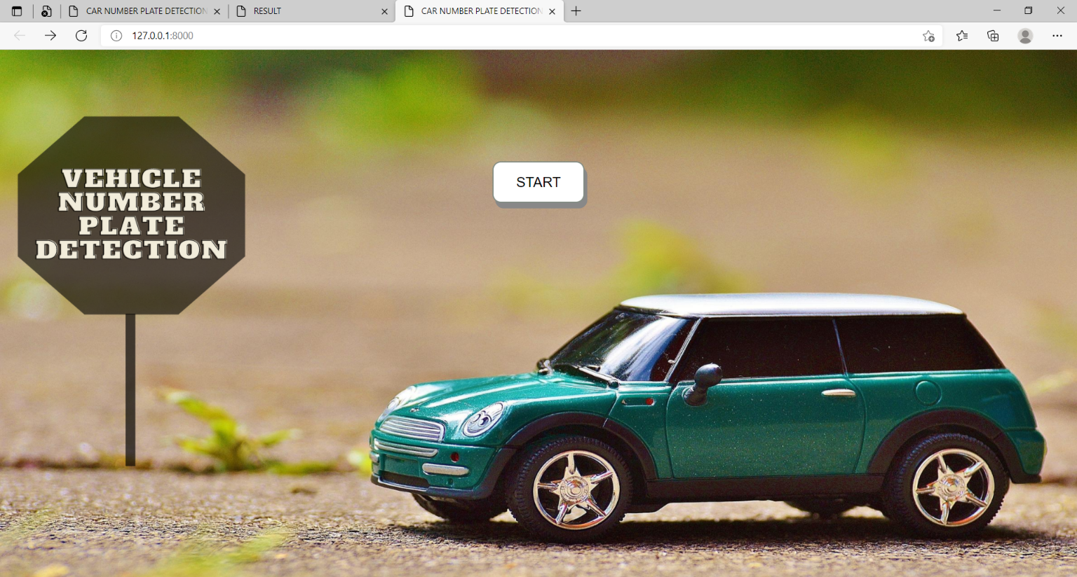
2. **IMAGE UPLOAD PAGE**

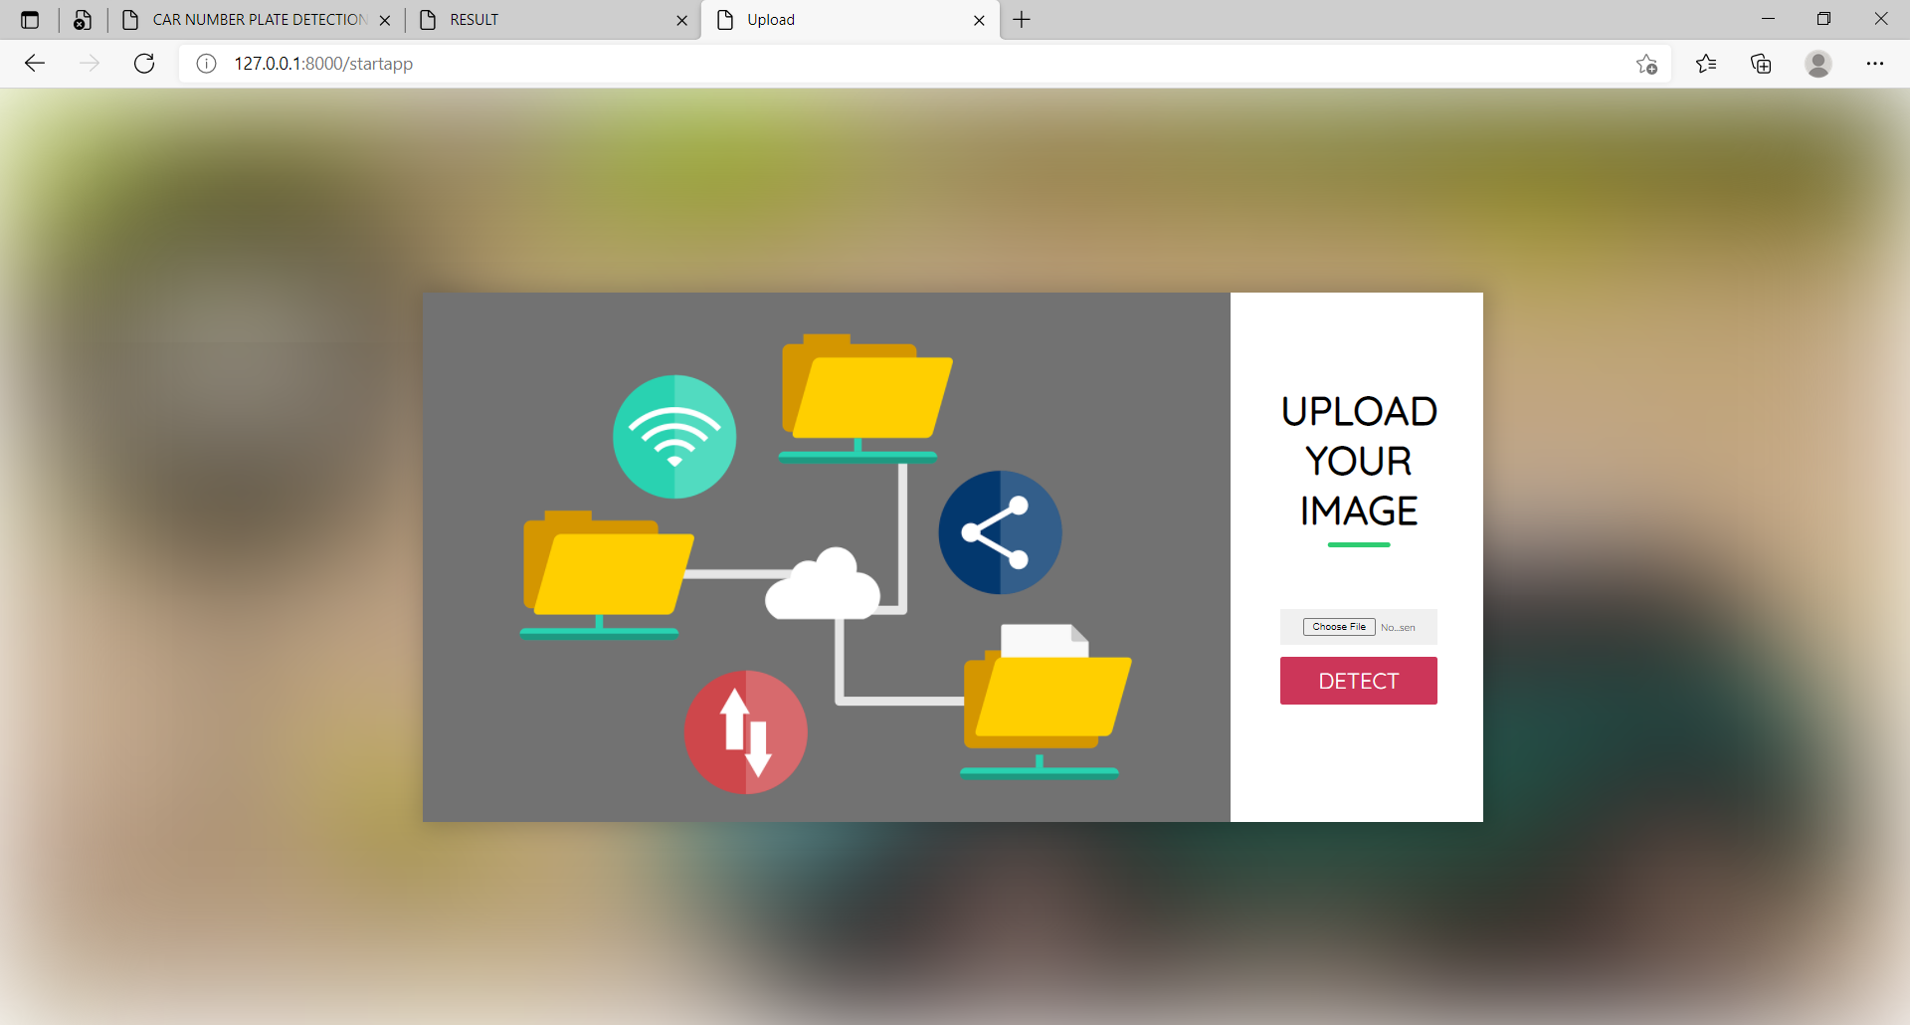

1. 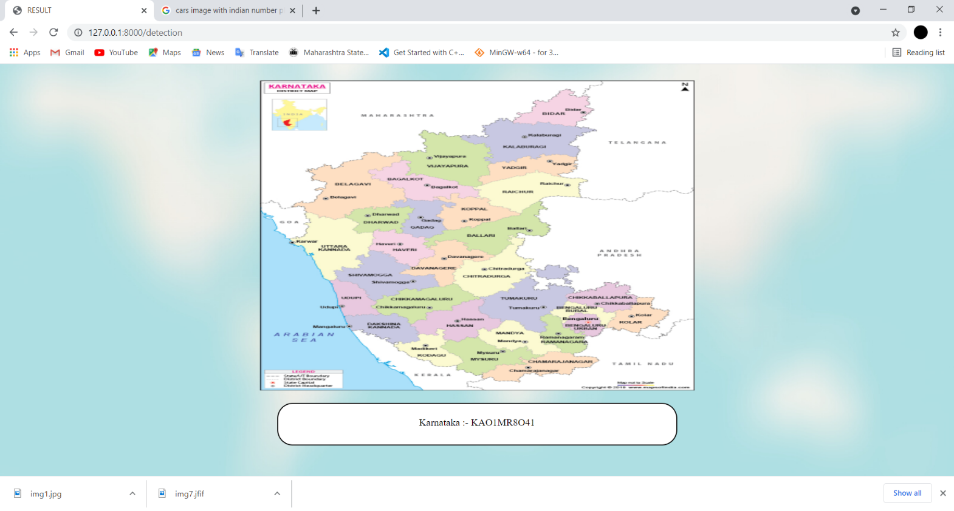**RESULT PAGE (PLATE NUMBER AND MAP)**
2. **OUTPUT OF YOLO MODEL**

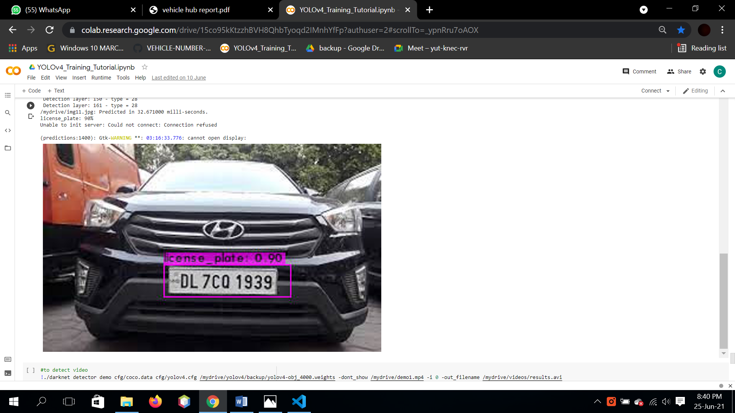

**CONCLUSION**

The project provides recognition method in which the vehicle plate image is obtained by the digital cameras and the image is processed to get the number plate information. A rear image of a vehicle is captured and processed using various algorithms.

The automatic vehicle identification system plays an important role in detecting security threat. The system use series of image processing techniques for identifying the vehicle from the database stored in the PC The system is implemented in PyCharm and its performance is tested on real images. The system robustness and speed can be increased if high resolution camera is used. Further we are planning to study about the characteristics involved with the automatic number plate system for better performance.

**REFERENCES:**

1. Automatic Identification of Vehicle Plate Number using Raspberry Pi Abayomi O. Agbeyangi; Olaitan A. Alashiri;Adeolu E. Otunuga 2020 International Conference in Mathematics, Computer Engineering and Computer Science (ICMCECS) Year:2020.
2. OCR-based chassis-number recognition using artificial neural networks Parul Shah;Sunil Karamchandani; Taskeen Nadkar;Nikita Gulechha;Kaushik Koli; Ketan Lad 2009 IEEE International Conference on Vehicular Electronics and Safety (ICVES) Year: 2009
3. MobLP: A CC-based approach to vehicle license plate number segmentation from images acquired with a mobile phone camera AbhishekSharma; AmeyDharwadker; Thotreingam Kasar 2010 Annual IEEE India Conference (INDICON)Year: 2010
4. Comparison in Depth Perception between Virtual Reality and Augmented Reality Systems Jiamin Ping;Yue Liu;Dongdong Weng 2019 IEEE Conference on Virtual Reality and 3D User Interfaces (VR) Year: 2019
5. Industrial Augmented Reality: Transferring a Numerical Control Connected Augmented Realty System from Marketing to Maintenance Christian Kollatsch;Marco Schumann;Philipp Klimant;Mario Lorenz 2017 IEEE International Symposium on Mixed and Augmented Reality (ISMAR-Adjunct) Year: 2017
6. Deep Statistical Analysis of OCR Errors for Effective Post-OCR Processing Thi-Tuyet-Hai Nguyen;Adam Jatowt;Mickael Coustaty;Nhu-Van Nguyen;Antoine Doucet 2019 ACM/IEEE Joint Conference on Digital Libraries (JCDL) Year: 2019